** Cairo University**

**Faculty of Computers and Artificial Intelligence**

**Department of Computer Science**

**Nutrients Tracker App**



**Supervised by**

**Dr. Khaled Wassif**

**TA. Randa Elbehery**

**Implemented by:**

**Alaa Farouk 20170058 CS_DS**

**Nada Mohamed Mahmoud 20170370 CS_DS**

**Naira Magdy Mohamed 20170326 CS_DS**

**Aya Amr Mohamed 20170359 CS_DS**

Graduation Project

Academic Year 2020-2021

Midyear Short Documentation

**Contents**

**1. Abstract 3**

**2. Background 3**

**3. Problem definition 4**

**4. Related work 4**

**5. Project specifications 5**

**5.1 Functional Requirements 5**

**5.2 Non-functional Requirements 8**

**5.3 Use-case 8**

**5.3.1 Use case diagram: 8**

**5.3.2 Use case description tables ………………………………………………………..9**

**[5.4 Class Diagram 12](#_Toc64526411)**

**[5.5 System architecture 12](#_Toc64526411)**

**[5.6 Sequence Diagram 13](#_Toc64526411)**

**[5.7 Entity Relationship Diagram (ERD) 14](#_Toc64526411)**

**[6. Work plan 15](#_Toc64526411)**

# **1. Abstract**

Downloading a nutrition app is easy, but finding one that accurately track calories by recognizing scanned food images, tracking its nutrients, saving its recipe and giving nutritional tips is a tougher task.

Nutrients Tracker App is a smart camera app that uses deep learning to track nutrition from food images by developing a model that combines a deep convolutional neural network (CNN) with a state-of-the-art detection strategy, and training this model using a wide database of food images. This app will also provide the user with texted recipes and will allow the user to create, share and like recipes.it also will allow the user to search for his friends and view and like their recipes.

## **2. Background**

This is Food Image Recognition App: a smart camera app that uses deep learning to track nutrition from food images. This App is a promising tool for the real-time identification of food and for providing nutrition guidance. The app must provide with important nutrition-related information (e.g., calories) for each food component detected by the CNN-based model.

Essentially the app doesn't rely on any manual data entry, so that achieve automatic food recognition and nutrition analysis, based on images from mobile cameras.

**Tools AND Programming Languages:**

* Python -TensorFlow: is an open-source platform for ML which we will use in Image classification for "Food Recognition Model"
* Keras: acts as an interface for the TensorFlow libraries.it is a high-level API to build and train models in TensorFlow.
* Java - Android: for mobile app, to apply models together and each project target.

**Databases:**

* Web Application Database: MySQL.
* Wide Dataset, which contains foods images for food classification.
* Nutrition Database feeds the app with nutrition info.

### 3. Problem definition

With the summer months approaching, there can be external pressures to get fit. Tracking your food and calories helps you to lose more weight and keep the weight off in the long run. Using an app to track your calories can be a healthy eating pattern depending on the individual and their needs and intentions; it can also be a behavior or symptom of those who suffer from eating disorders, obsessive compulsive disorder, or even anxiety. Providing an app to motivate you by giving you healthier recipes and tips added to tracking your food can help more.

#### 4. Related work

**a) Lose It! – Calorie Counter**

Based on your weight, height, age and goals, Lose It! provides a personalized recommendation for calorie intake. It then tracks your calories on the home page.

Additionally, the Lose It! app has a barcode scanner for packaged foods, and common foods are saved for quick entry later on.

Lose It! presents weight changes on a graph, provides access to an active chat community and keeps a daily and weekly total. Its tab called “challenges” allows you to participate in dietary challenges or make your own.

**b) MyFitnessPal**

MyFitnessPal is one of the most popular calorie counters right now. It tracks your weight and calculates a recommended daily calorie intake. It also contains a well-designed food diary and an exercise log. The homepage provides a clear picture of how many calories you have consumed during the day.

In addition, it shows also the number of calories you have burned by exercising. The app also saves your favorite meals for convenient logging. MyFitnessPal has the largest database available in a diet tracker and includes many restaurant foods. It can download recipes from the internet and calculate the calorie content of each serving.

THE MAIN DIFF: Nutrients Tracker App provides a list with your favorite recipes and another list for you to created and added recipes. Also it allows you to search for a friend and see his added recipes. MyFitnessPal provide an exercise log and has the largest database available in a diet tracker Lose It! – Calorie Counter has “challenges” allows you to participate in dietary challenges make your own and also has barcode scanner for packaged food.

##### 

##### **5. Project specifications**

###### **5.1 Functional Requirements**

* **5.1.1. Signup**

User should be able to register into the system to be able to use its functionalities.

* Registration process needs user’s info (Email, User name, Password, Name, Gender, and Phone Number).
* The system checks whether the username and email had been used before, if it is not it will be create new account. Otherwise, the system will ask to enter a new email/username.
* After a successful registration, a new account will be saved in the database and redirects him / her to the main page.
* **5.1.2.** **Login**

User should be able to login into the system to be able use its functionalities.

* The System will allow the users who have account before to login into the system with registered email or username and password.
* The system checks whether the login information is correct.

If yes, it creates a session for the user and redirects the user to the main page.

Otherwise, the system redirects the user to the login page to try again.

* **5.1.3.** **Search users**

Logged user should be able to search for any user in the app by the username to be to view users’ profile.

* **5.1.4.** **View Profile**

Logged user should be able to view his profile and other users' profile that Allows the user to do some functionalities.

* + **5.1.4.1. View My profile**
    - **5.1.4.1.1. Edit profile**
* Logged user should be able to edit his registered information after view his profile and choosing this option.
* The system will update the new information in the database then redirects the user to his profile page.
  + - **5.1.4.1.2. View my favorite list**
* Logged user should be able to view his Favorites list in his profile.
  + **5.1.4.2. View Users’ profile**
* **5.1.4.2.1. Add to favorite list**
* Logged user should be able to add other users' recipes in his

Favorite list.

* **5.1.4.3. View Recipe list**

Logged user should be able to view his own recipes in his profile and also can view users' recipes in a users' profile.

* **5.1.4.3.1. View recipe details**
* Logged user should be able to view all details of a specific recipe and its nutrients by click on the recipe in the recipe list.
* **5.1.5. Access Camera**

The System will ask the new user after signup to confirm accessing his smart phone camera to be able to open the camera and take a photo of his meal.

* **5.1.6. Scan Food**
  + The system checks if the user give the system the permission to open his phone camera before open it. If it is not, the system ask user to allow camera access.
  + Logged user should be able to open the mobile camera and point it to a plate containing his meal to take a photo.
  + The system use the photo to track the nutrients for each ingredients.
* **5.1.6.1. Recognize Food**

The System will Recognize food name and detect its ingredients after the user

takes the photo of his meal.

* **5.1.7.** **Add Recipe**
* Logged user should be able to create his food recipe and track the recipe nutrients
* The system will save it in the database to view it in his profile.
* **5.1.8. Search food**

Logged user should be able to search for specific foods to track its nutrition facts.

* **5.1.9. Calculate Nutrients**

The System will display table of all the nutritional facts as (Carbs, Fat, Protein, Sugar, Fiber, cholesterol, vitamins ... etc.)

* **5.1.10. Macro Tracker**
* Logged user should be able to request to reduce/increase the Marcos (carbs, fats, protein) in his recipe or other users' recipes.
* The System will suggest ideas and some tips based on his request.
* **5.1.11. Log out**
* Logged user should be able to choose to log out from the system. By choosing this option in his profile.
* The system closes the open logged user session and redirects the user to the Start page.

**5.2 Non-functional Requirements**

|  |  |
| --- | --- |
| Performance | All operations that need system response should be done in less than 5 Seconds. |
| Usability | The apps interface will be user friendly that the users will become familiar with it after logging in and using it few times. |
| Availability | The application will not fail for no more than one percent a day. |
| Security | The Application will store all user data by encrypting and decrypting. |
| Maintainability | It will be easy to find bugs and fixes them. |
| Reliability | There is a 98 percent chance that the system will not experience critical failure and will recognize all the ingredients of a scanned photo or it will display an error message. |

**5.3 Use-case**

**5.3.1 Use case diagram:**

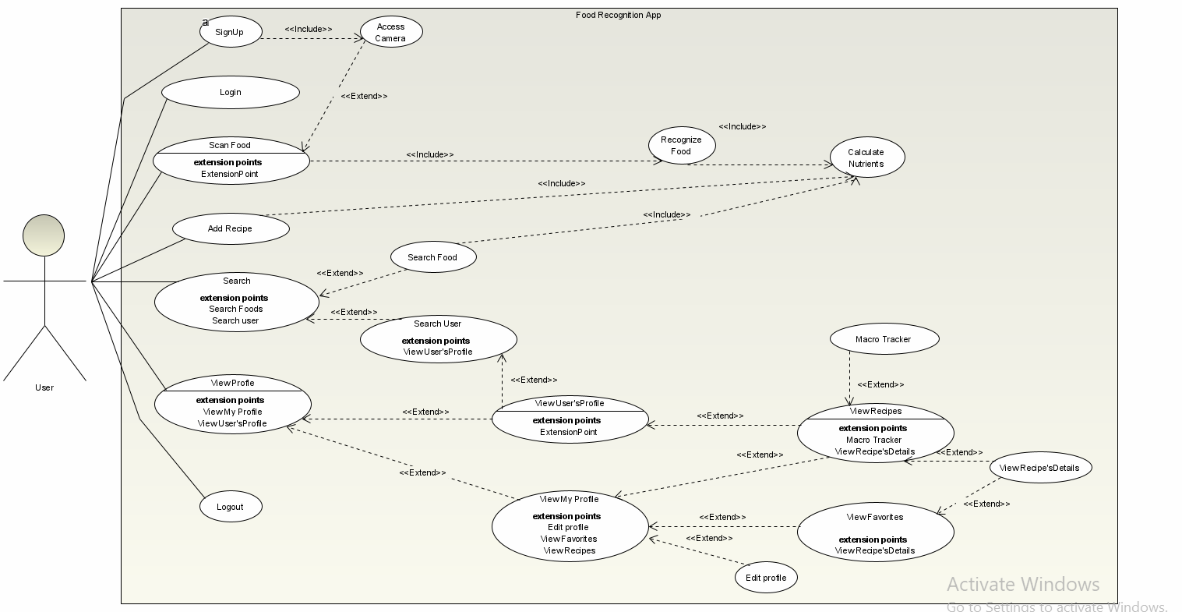

**5.3.2 Use case description tables:**

**5.3.2.1. Register**

|  |  |  |
| --- | --- | --- |
| Use Case ID: | 5.1.1 | |
| Use Case Name: | Register | |
| Use Case Description: | The System will Allow the new users to sign up by entering their personal information (User name, gender, phone number, email, Password) to create a profile. | |
| Actors: | User | |
| Pre-conditions: | User initiates the registration process. | |
| Post-conditions: | User Successfully registered into the system. | |
| Flow of events: | **User Action** | **System Action** |
| 1- User Enters required information: Username, Gender, Phone-Number, Name, Email, and Password. |  |
|  | 2- System Verify that all fields are completed. |
|  | 3- System Create a profile to the user. |
|  | 4-System will ask user to access his mobile phone’s camera |
| 5-User enters allow button |  |
|  | 5- |
| Exceptions: | **User Action** | **System Action** |
| 1- User Enters Invalid Information doesn’t match the requirements. |  |
|  |  |
|  | 2-System Prompts the user to re-enter the information. |
| Includes: | Access Camera | |
| Notes and Issues: |  | |

**5.3.2.2. Add Recipe**

|  |  |  |
| --- | --- | --- |
| Use Case ID: | 5.1.7 | |
| Use Case Name: | Add Recipe | |
| Use Case Description: | The System will allow the user after creating his food recipe to save it in his profile. | |
| Actors: | User | |
| Pre-conditions: | User logged into the system. | |
| Post-conditions: | User Successfully Add his Recipe. | |
| Flow of events: | **User Action** | **System Action** |
| 1-User Clicks on add recipe button. |  |
|  | 2-System will ask user to enter some information. |
| 3-User Enters the required information (Recipe Name, Ingredients, and Steps) for the recipe. |  |
| 4-User clicks on Save Button. |  |
|  | 5- System will Verify that all fields are completed. |
|  | 6-System will use the ingredients to calculate the nutrients. |
|  | 7- System saves the recipe in the database. |
| Exceptions: | **User Action** | **System Action** |
| 1- User Enter invalid information doesn’t match the requirements. |  |
|  | 2- System Prompts the user to re-enter the information. |
| Includes: | Calculate Nutrients | |
| Notes and Issues: |  | |

**5.3.2.3. Scan Food**

|  |  |  |
| --- | --- | --- |
| Use Case ID: | 1.12 | |
| Use Case Name: | Scan Food | |
| Use Case Description: | The System will allow the user to point his camera to a plate containing a meal. | |
| Actors: | User | |
| Pre-conditions: | User logged into the system and accessing his phone’ camera. | |
| Post-conditions: | User Successfully taking a photo of food and detecting food’s name and ingredients. | |
| Flow of events: | **User Action** | **System Action** |
| 1-User Clicks on Scan Photo button |  |
|  | 2-System opens camera to allow user to take photo. |
| 3-User Takes a photo a plate of food. |  |
|  | 4- System saves the photo and sends it to the recognition Model to return Food name and its ingredients. |
|  | 5- System will use the ingredients to calculate the nutrients. |
| Exceptions: | **User Action** | **System Action** |
| 1- User doesn’t access his phone camera. |  |
|  | 2-System will ask him to access his phone camera. |
| 1-User take a photo doesn’t containing food. |  |
|  | 2-System will ask the user to take another photo. |
| Includes: | Recognize Food – Calculate Nutrients | |
| Notes and Issues: |  | |

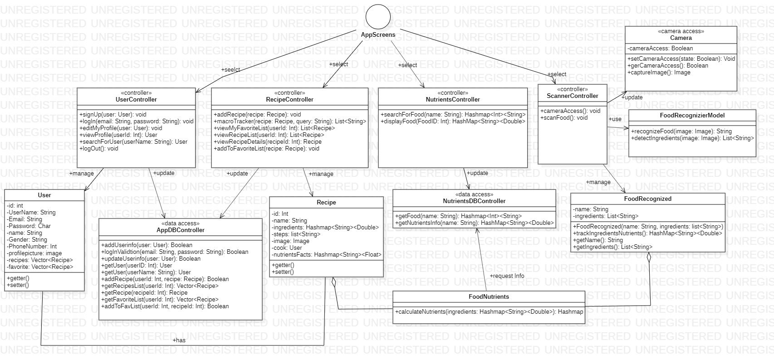**5.4 Class Diagram**

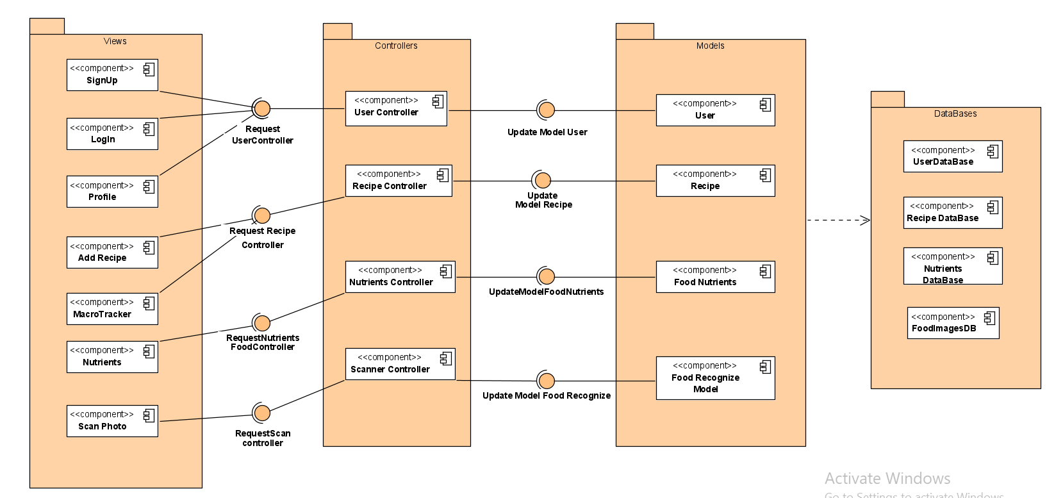**5.5 System architecture**

**5.6 Sequence Diagram**

**5.6.1. Scan food**

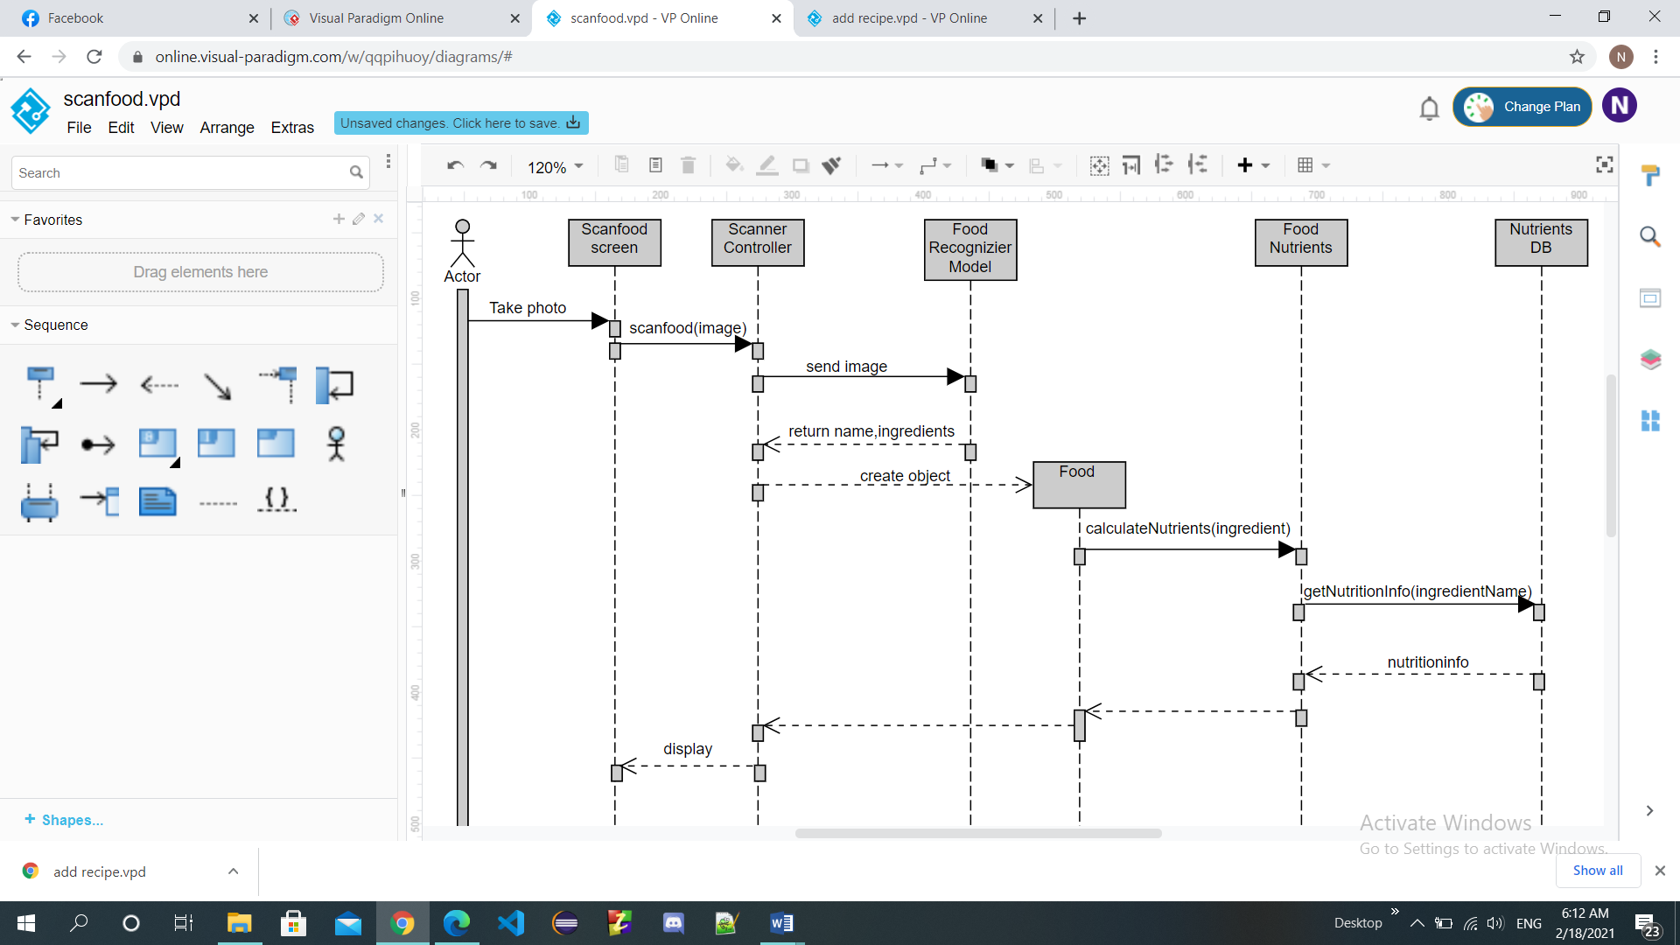

**5.6.2. Add Recipe**

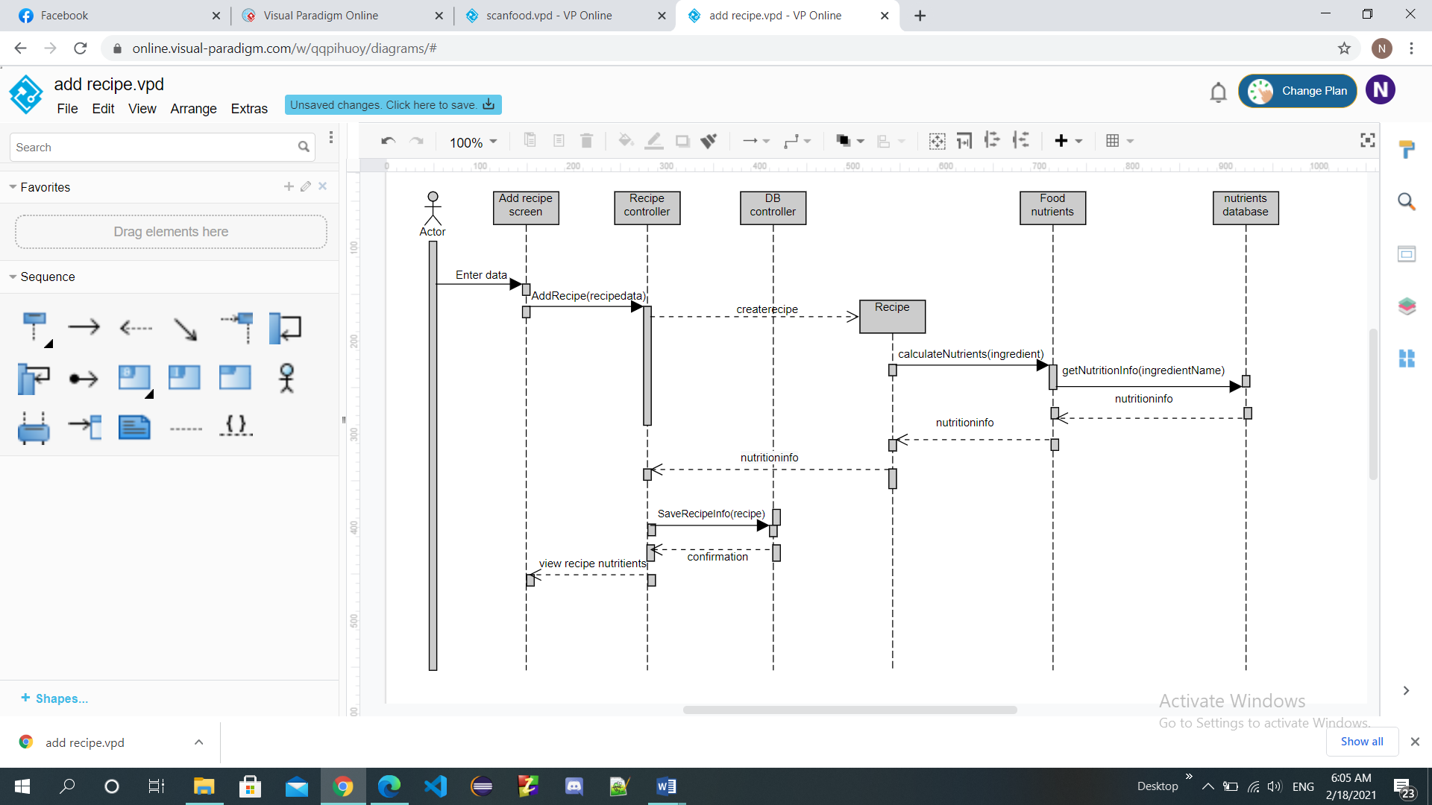

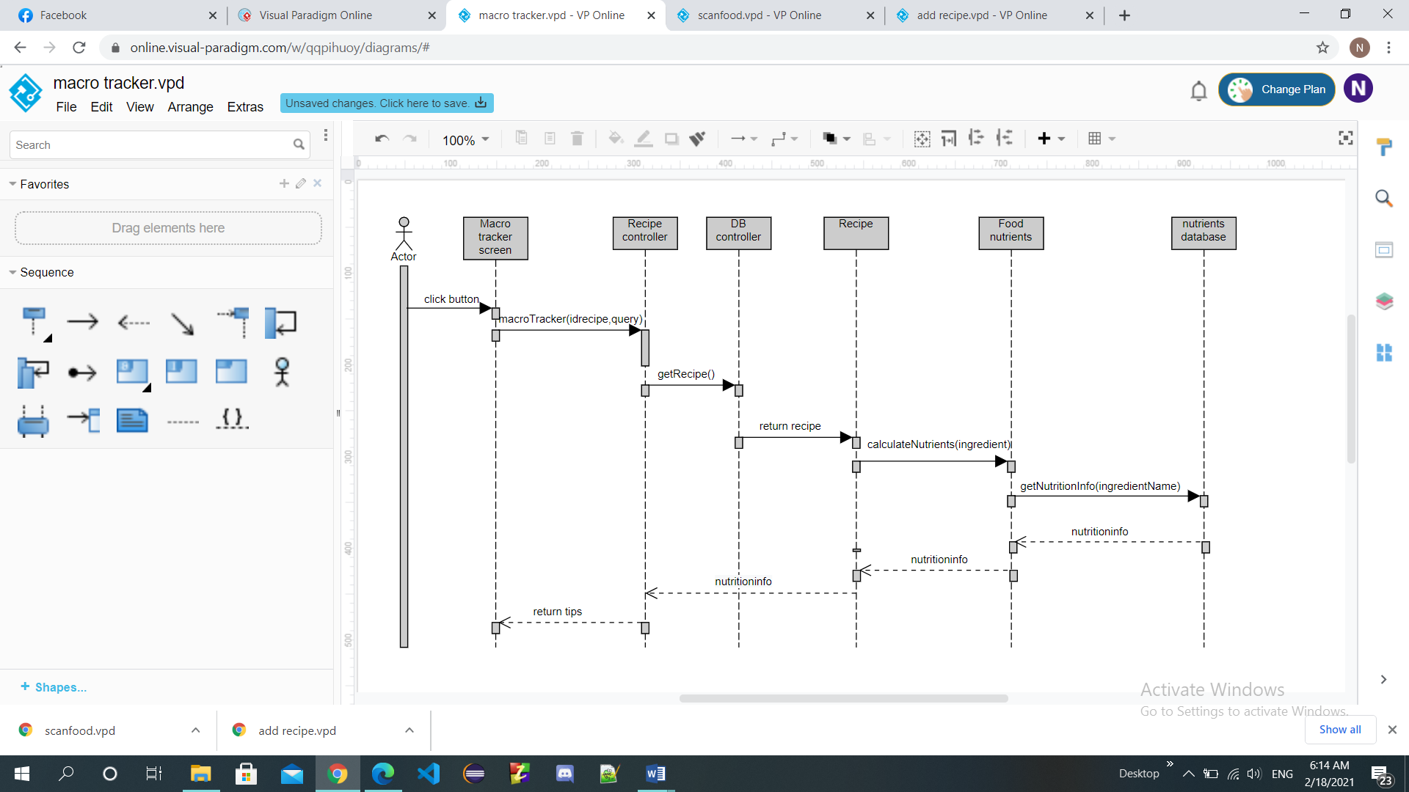**5.6.3. Macro Tracker**

**5.7 Entity Relationship Diagram (ERD**)

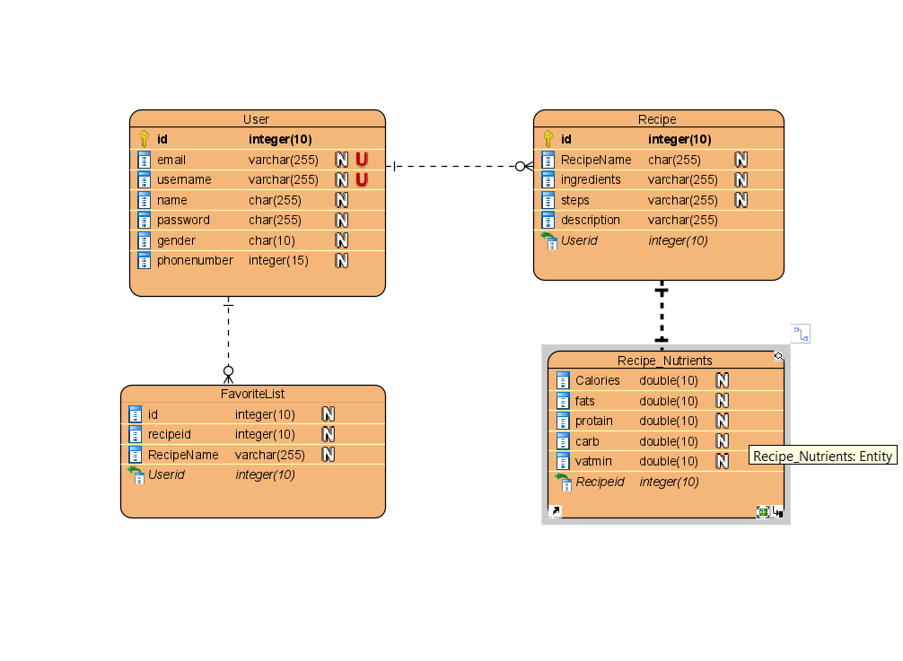

**6. Work plan**